The Coalition for Agricultural Development
FY 2014 Issues Paper

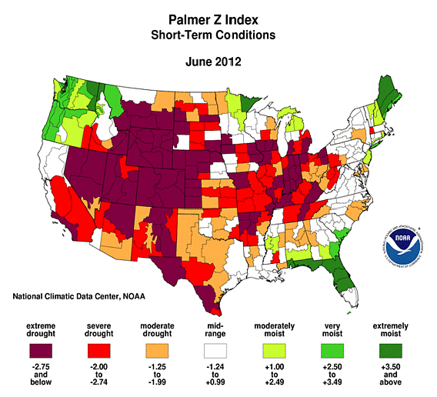
In 2012, many American farmers and ranchers found themselves in the middle of the production season facing drought conditions more severe than they had experienced in decades (see map). Thanks to government-supported crop insurance, flexible markets, and good on-farm management techniques, row crop producers were able to adapt even as their yields declined significantly. In fact, as grain prices rose higher in response to the projected production shortfalls, farmers’ income levels did not decline as much as earlier predicted. Although dairy, livestock and poultry producers were not as well protected, especially as feed costs rose and pasture conditions declined, consumers in the United States barely noticed as the Consumer Price Index for food rose less than two percent in 2012. However, the droughts in the U.S., Central Asia, and Eastern Europe did lead to an overall spike in world cereal prices. And, because the affected regions are large producers of key staple crops, the drought will have implications for global food security through upward pressure on prices well into 2103.

Farmers and consumers in food-insecure areas of the developing world are not as fortunate.

Crop and livestock producers in Africa and South Asia do not enjoy the productivity or resilience experienced by American farmers and ranchers. The result is both economic and nutritional vulnerability for producer families. Their productivity is already low and when drought or excess rainfall threaten or destroy crops in these regions, neither privately-funded nor publicly-subsidized insurance mechanisms provide a safety net. In Africa, resilience of chronically vulnerable populations to crisis is particularly weak. As noted by IFPRI: “Crop production rebounded in the Sahel region in Africa [in 2012] following the 2011 drought, but closer inspection of the Sahel crisis suggests that current food insecurity there is more a reflection of the region’s chronic, long-term vulnerability…The resilience of chronically vulnerable communities in the region to crisis is weak. Farmers barely had time to recover and rebuild already limited assets after previous droughts before the drought of 2011 hit the Sahel.”

Irrigation capabilities are considered by many to provide South Asian farmers with significant yield and income stability but, in sub-Saharan Africa, where only four percent of the land is under irrigation, even this form of production insurance is not widely available. When endemic diseases such as Rift Valley fever or East Coast fever strike East Africa’s cattle herds, quick access to veterinary services and appropriate treatments is not always assured. Losses can be severe, disrupting markets for meat and milk, bankrupting herding families, or even causing human diseases among herders’ families. When insects or diseases invade fields and grazing lands, there are too few remedies to avoid devastating impacts on yields and profits. Breeding of crops for tolerance or resistance to drought, insects, and diseases is, for many farmers and ranchers, as important as breeding for higher yields. And development of resource management approaches, such as rain harvesting technologies or on-farm natural regeneration of trees, is critical to reducing risks for those in the most drought-prone areas.

When production or incomes fall, farm families must adjust their consumption patterns, frequently with seriously negative impacts on their nutrition levels. Poor urban households, who spend more than half of their incomes on food, may find it difficult to meet the higher prices caused by deficits. In East Africa, for example, the “short rains” that occur between October and December normally supply farmers in many areas of Kenya, Ethiopia, and Somalia with sufficient moisture to make this the principal crop season. In 2012, these rains were erratic, with a delayed start and poor spatial and temporal distribution. Some farmers replanted maize and sorghum crops up to three times, as these crops provide up to 60% of their food and income, but most are likely to get significantly reduced yields in this 2012/2013 season. While the food security situation is now categorized as “stressed” for much of the Horn of Africa, many areas have already been flagged by USAID’s Famine Early Warning System as “in crisis,” reinforcing again the close linkages between production and family food security.

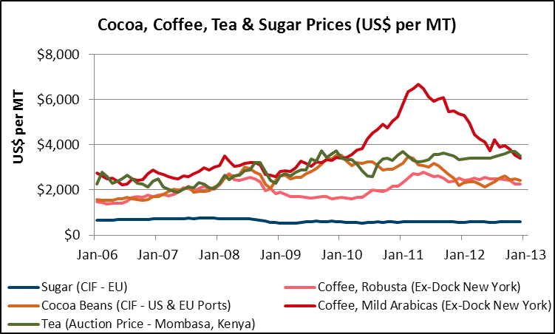
Banks and other financial institutions extend little production credit to smallholder farmers, especially in Africa. In part, this is because smallholder farmers own few assets (including land) that they can offer as collateral for loans and, in part, because they are high-risk borrowers, with their production subject to adverse weather and varying market prices. Vertically-integrated production operations, in which larger producers or processors buy raw commodities from smallholder producers and provide inputs on credit to ensure sufficient output, are relatively common in certain sectors: cotton, sugar, horticultural products for export, coffee, and tea. These operations support smallholders’ production but they provide little in the way of buffers for the price variability that characterizes competitive global markets for these important agricultural exports (see graphic).

Development interventions are needed to build greater resilience in the food and agriculture sector.

What is needed to make African and South Asian farms and livestock operations more productive and resilient? The United States has joined with many other countries and private sector companies to take up this challenge. The U.S. government’s contribution to this global effort is called Feed the Future. Through its leadership in implementation of Feed the Future, USAID is increasing productivity of smallholder farmers and livestock owners in the 19 Feed the Future focus countries, seeking to achieve the goal of sustainable intensification by increasing the production per unit of land without harming the environment. However, as the drought of 2012 reminded all Americans, it is important to address the issue of resilience in less-than-ideal weather conditions as well. In order to assure national food availability and affordability, all governments have a role to play in assuring that food and agricultural systems are robust, productive, and able to survive setbacks. How can the U.S public sector contribute most effectively, in partnership with other donors and the private sector to this dual agenda? Some areas of focus are clear:

- Global and national public policies that make strengthening food and agricultural systems the highest priority, especially ensuring that public investments in the institutions and infrastructure continue over enough years to make those systems work.

Improving agricultural productivity and resilience requires action and investment all along the value chain. Food and agricultural systems cannot operate efficiently if: there are too few technically and scientifically skilled people in developing countries to create and adapt technologies that increase productivity; institutions are not able to provide the quality education needed to develop those skills; roads to transport goods to market are non-existent or in poor repair; market information is not regularly and freely available to rural farmers seeking to sell their produce; private agribusinesses lack incentives to invest in storage and processing facilities; there are no trusted public institutions to safeguard the safety of a nation’s food supply; and food wholesalers and retailers face government-imposed price controls that make it impossible to operate profitably. Recent research in Asia has shown that strategic investments by governments, e.g., in energy systems and cold storage facilities for potatoes, can leverage significant private sector investment and improve the efficiency of transactions in the value chain while ensuring a flow of commodity to consumers year-round.

- Consistent public support for agricultural research and technology innovations and for extension efforts carried out by both public and private institutions, including universities that, as in the U.S. land grant system, combine the mandates of education, research, and community service.

New and better crop varieties and livestock breeds are essential drivers for increased on-farm productivity. The new tools of microbiology, biotechnology and genomics are critical to their development, as they can accelerate the identification and selection of more productive or disease-resistant materials. But it is also important to search for better methods of managing soil and water, ensuring efficient applications of fertilizer and other inputs, and reducing post-farm losses through innovative storage and processing options. Further, smallholder farmers must be able to understand and apply these new technologies, adapt them where necessary, and be encouraged to interact with scientists, extension educators and others – both local and from the international community -- to ask for innovations they believe would help them become both more productive and more resilient in the face of climate change, shifting markets, and demographic stress.

- Donor and country-based incentives, as well as regulations that facilitate expansion of farming as a profitable business, supported by efficient private markets for commodities, farm credit, and agricultural supply inputs and services.

Smart subsidies, such as vouchers that can be redeemed at private agro-dealers to reduce fertilizer costs or to introduce farmers to improved seeds or veterinary products, may be a way for governments to provide short-term incentives to farmers and, at the same time, to partner with private farm input suppliers in building larger markets for these products. But governments also need to ensure that systems are in place to certify improved seeds and vaccines as well as to license private seed producers/dealers and skilled veterinary service providers. Public guarantees of loans from privately-owned banks can help to expand available farm credit, but governments also need ensure that credit regulations are clear and enforceable. Governments and private agribusinesses may work together to define appropriate standards for trade in agricultural commodities, both raw and processed, but once established, government inspection services need to ensure fair and adequate application of these standards by the competitive private sector.

- Support for continued capacity building, education and training to increase the management capabilities of smallholder farmers and livestock owners, both women and men, as well as to raise the knowledge and skill levels of the students who will go on to teach, do research, run agribusinesses, and provide sector governance.

Building more productive and resilient agricultural systems will require farmers and livestock owners who are able to assess and take risks, manage their operations to minimize risks, and understand the potential of new tools (insurance, production contracts, irrigation, leasing arrangements) to mitigate those risks. Traditional extension services or advisory services from private sector agribusinesses can provide some of the education and training needed and can be complemented by new forms of communication and training – such as cellphones or video technologies. Technical schools and universities will also play critical roles in capacity building for the future. Well-trained specialists working in well-functioning universities, research centers, private businesses, and government institutions will be needed to adapt food and agriculture systems to evolving conditions over the decades to come.

- Provision of healthcare support services and programs that can help families –especially mothers and young children – to achieve improved nutritional outcomes with the food and incomes at hand.

Hunger and malnutrition, while declining, remain all too common among farming families in both South Asia and sub-Saharan Africa. Illness of a working adult family member can transform a family’s livelihood outlook overnight. Addressing the challenges of increasing food production and labor productivity will help to address these problems, but access to healthcare and nutrition education is also critical for rural households. Key outcomes to increase household resilience are reduction of the incidence of infectious diseases, provision of clean water and improved sanitation facilities, and expanded knowledge of and training in effective childcare and child nutrition practices, particularly improving nutrition for mothers and children in the first 1,000 days of a child’s life.

Climate variability has underlined the need to do more to simultaneously increase productivity and the resilience of production systems and farm families.

In the United States, the U.S. Department of Agriculture (USDA) has recognized this in issuing a new report that focuses on the adapting highly-productive American agricultural systems to the challenges of climate change. Developing country governments partnering with the U.S. in Feed the Future programming have recognized the need to mobilize new tools and techniques to simultaneously increase the productivity of their food and agriculture systems and their resilience to stresses and are working on that objective. Many governments in sub-Saharan Africa and South Asia are looking for help to develop more “climate smart” approaches to agriculture, especially where current production levels are well below potential yields.

A number of partners have already joined in this effort. The U.S. universities that have been long involved in Collaborative Research Support Programs are raising their level of effort in “Innovation Labs” and they, along with others, are conducting rigorous impact evaluations to better understand what works and what does not. The Consultative Group on International Agricultural Research (CGIAR) has included in its research portfolio a major global program on Climate Change and Food Security (CCAFS). International organizations such as the Food and Agriculture Organization (FAO), the World Bank, the International Fund for Agricultural Development (IFAD), and the Organization for Economic Cooperation and Development (OECD) have joined together in a consortium to explore mechanisms for advancing the understanding and practice of climate smart agriculture. A number of non-governmental organizations (NGOs) have created a new platform for collaboration called Landscapes for People, Food and Nature. All of these initiatives, and many national programs in the developing world, are intended to enable farming families to increase their productivity and food security in good-weather years while protecting their livelihoods and nutrition in those years when conditions are less than ideal.

Finding ways to reduce weather risks is an important element of any climate-smart investment plan. Drought-tolerant or flood-resistant varieties are one approach being supported by Feed the Future. Investments in irrigation, especially in sub-Saharan Africa, are another. Better weather monitoring, conservation tillage techniques, and improved crop/livestock management approaches provide further resilience to farming populations. Pilot insurance programs are also demonstrating a way forward. And food assistance – whether internationally-provided or delivered as part of a national food safety net – is a critical part of the “resilience” toolkit. Food aid is life saving and makes an immediate difference for severely stressed populations and help rural families to protect their assets for recovery. It also supports longer-term development programming. Food aid is a critical part of an overall package of investments, but it is only by making a continuing investment in, and commitment to, productive and profitable local food and agricultural systems that countries will achieve long-term food security.

U.S. policy, global investments, and agricultural development assistance continue to be important mechanisms for supporting the realization of a sustainable, food-secure future for all.

The innovative spirit that has enabled American agriculture to be both productive and resilient is urgently needed in the food-insecure and agriculture-dependent countries of sub-Saharan Africa and South Asia. The whole-of-government approach that underpins the implementation of Feed the Future enhances USAID’s ability to draw on America’s own experience to craft promising solutions in partner countries. Recent tests of insurance mechanisms demonstrate just such innovative thinking.

In 2011, USAID launched a three-year partnership with Swiss Re, a global leader in innovative risk management solutions. This initiative drew support from two USAID programs: The Global Climate Change Initiative, which aims in part to increase resilience to extreme climate events and accelerate the global transition to a sustainable, low-carbon economy; and the Feed the Future initiative, the U.S. Government's global hunger and food security effort to help countries develop more resilient and productive agricultural sectors to address the root causes of hunger and under-nutrition. For example, an innovative index-based livestock insurance project in Kenya, developed by collaborative efforts of U.S. universities and a CGIAR center, enabled drought-affected pastoralists in 2011 to avoid selling off their assets, reducing their food intake, or searching for food aid. With better access to such customized, market-based insurance products, poor farmers and their families will be better able to prepare for and cope with the impacts of the droughts, floods and other severe weather events that are predicted to become increasingly common as the climate changes. When farmers have better instruments to manage risk, they can more easily obtain the loans needed to invest in technologies that increase their yields and productivity, and have greater incentive to make those investments, knowing that they are buffered from extreme weather events.

Feed the Future is aimed in the right direction and mobilizing new tools and partnerships to build momentum toward increasing agricultural productivity and resilience. To complete the journey, USAID and its partners required sustained financial and political support, encouragement to undertake course corrections based on sound monitoring and evaluation efforts, and full participation of a broad community of contributors -- scientists and innovators, teachers and students, entrepreneurs and investors, public leaders and advocates from civil society, food processors and consumers. The package of FY 2014 global food security appropriations supported by CFAD can help to make this happen.

International Food Policy Research Institute 2012 Global Food Security Report, Washington, DC, 2013, p. 2
International Food Policy Research Institute 2012 Global Food Security Report, Washington, DC, 2013, p. 3
http://www.fews.net/docs/Publications/East_Seasonal_Monitor_01_2013_en.pdf
Bloom, D. et al. (2006) “Higher education and economic development in Africa.” Human Development Sector, World Bank.
http://www.ifpri.org/sites/default/files/publications/quiet-revolution-staple-food-value-chains.pdf
USDA Climate Change and Agriculture, Feb. 4, 2013.
http://ccafs.cgiar.org/
http://www.climatesmartagriculture.org/en/
http://landscapes.ecoagriculture.org/
http://feedthefuture.gov/model/usaid-and-swiss-re

